**Math 120  
4.2 Logarithmic Functions**

# **Objectives:**

1. Change from logarithmic to exponential form.
2. Change from exponential to logarithmic form.
3. Evaluate logarithms.
4. Use basic logarithmic properties.
5. Graph logarithmic functions.
6. Find the domain of a logarithmic function.
7. Use common logarithms.
8. Use natural logarithms.

# **Topic #1: Definition of Logarithmic Functions**

REMINDER:

Recall that inverse functions “switch” the x and the y-values on the graph and in the equation.



Example: Equation:



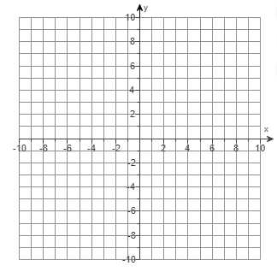

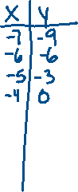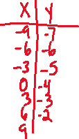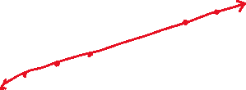

Equation:

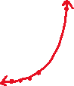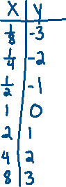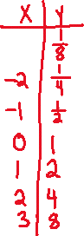

When taking the inverse of exponential functions, we run into a problem actually solving the equation. But we know exactly how this inverse function should behave. So, mathematicians defined a new type of function that acts as the inverse of an exponential function.



This is called a ___________________________.



Consider the equivalent statements that show the inverse relationship between exponents and logarithms:



This provides the definition of a logarithmic function:



where is the base of the logarithmic function.

The function is read “y equals log base b of x”. As with exponential functions and . Unlike exponential functions, the domain is restricted to



Consider the graph of the functions and

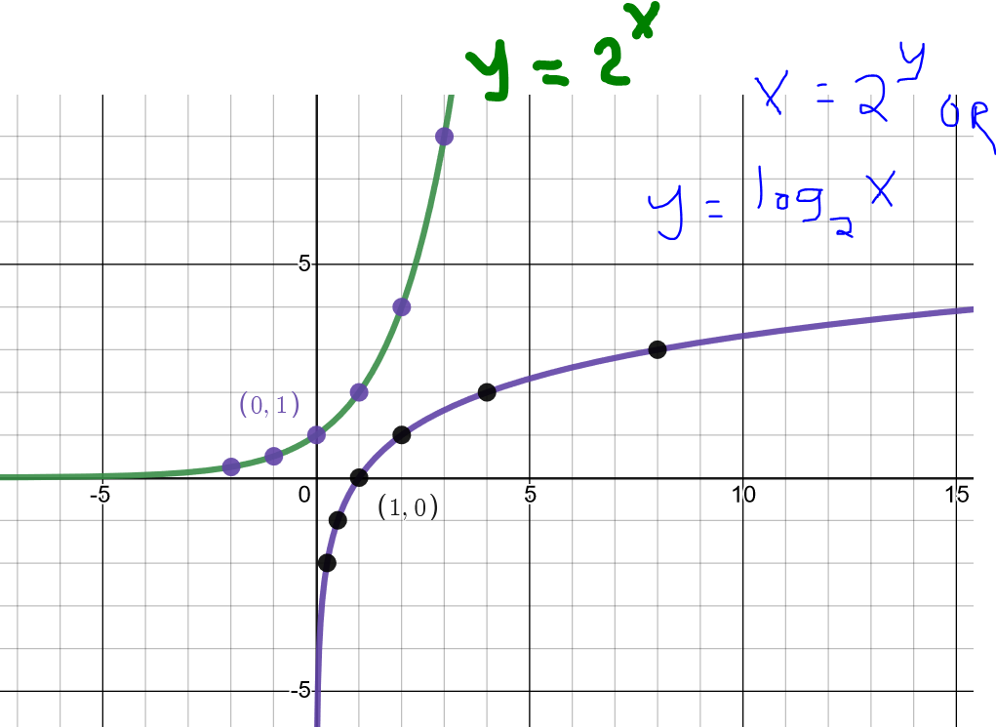

Notice the points are reversed, showing the two functions are inverses! The exponential function has an horizontal asymptote at ________________________



and the logarithmic function has a vertical asymptote at



*Example #1* – Sketch a Graph of the Logarithmic Function

a)



By definition, this is equivalent to and is the inverse to the exponential function . We can use some points from the exponential function to get points for the logarithmic function.

| x | -3 | -2 | -1 | 0 | 1 | 2 | 3 |
| --- | --- | --- | --- | --- | --- | --- | --- |
|  |  |  |  |  |  |  |  |

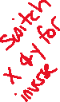

| x | 1/27 | 1/9 | 1/3 | 1 | 3 | 9 | 27 |
| --- | --- | --- | --- | --- | --- | --- | --- |
|  |  |  |  |  |  |  |  |

The exponential function has **domain** _____________and **range** ___________________



Therefore, the logarithmic function has **domain** ______________and **range** ___________________



The exponential function has a **horizontal asymptote** at



Therefore, the logarithmic function has a **vertical asymptote** at



The exponential function increases RAPIDLY, the logarithmic function increases SLOWLY.

A graph confirms:



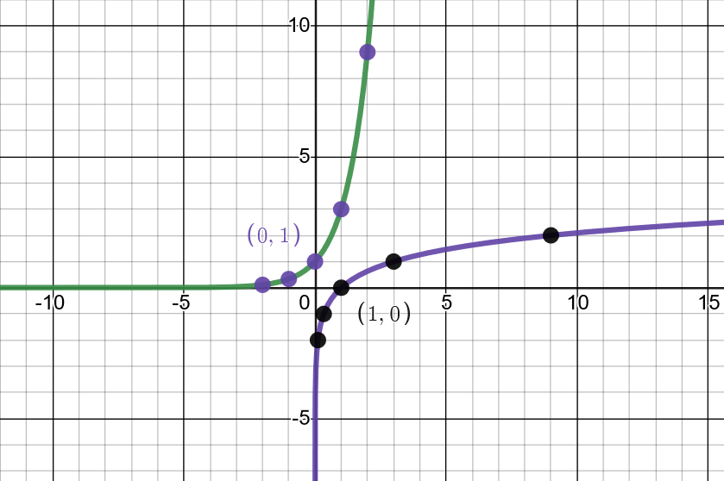



# *Example #2* – Use the Definition to Rewrite the Logarithm Equation in Exponential Form

a)

Apply the definition:



b)

Apply the definition:



c)



Apply the definition:



*Example #3* – Use the Definition to Rewrite the Exponential Equation in Logarithm Form

a)

Apply the definition:



b)



Apply the definition:



c)



Apply the definition:



*Example #3* – Use the Definition to Rewrite; Radicals Involved

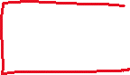

a)



b)



c)

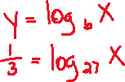

d)



# ***Topic #2: Evaluating Logarithmic Expressions with Definitions and Properties***

It is worth stating multiple times – here is the definition of logarithm:



Certain logarithmic expressions can be evaluated without a calculator by using what we know about their exponent counterparts. For example, we can evaluate:



Then we can rewrite as an exponential equation using the above property:



Finally, we can use trial and error OR what we know about base 2 numbers:



*Example #1* – Use the Definition of Logarithm to Evaluate the Expression

a)



Write as an equation, then write as an exponent:



b)



Write as an equation, then write as an exponent:



c)



Write as an equation, then write as an exponent:



d)



Write as an equation, then write as an exponent:



e)



Write as an equation, then write as an exponent:



f)



Write as an equation, then write as an exponent:



g)



Write as an equation, then write as an exponent:



Note: Perhaps not all the answers are obvious and might require some trial and error. However, the more important part is to understand that **logarithms are __________________________________**



# **Topic #3: Basic Logarithmic Properties**

The definition of logarithm:



Can be used to develop the 4 basic properties:

**1.**



**2.**



**3.**



**4.**



For example, the first property must be true since any base to the power ZERO is ONE. Rewriting the exponential fact as a logarithm shows the property:



The second property must be true since any base to the power of ONE is ITSELF. Rewriting this fact as a logarithm shows the property:



The third and fourth properties can be reasoned with similarly, but they can also be explained by the inverse relationship between logarithms and exponents. The third property states that a ______________________, the fourth states that an __________________________.



*Example #1* – Use a Basic Logarithmic Property to Evaluate the Expression

a)



Use property two:

b)



Use property one:

c)



Rewrite the radical as an exponent and use property three:

d)



Use property three:



e)



Rewrite the fraction as an exponent and use property three:

f)



Use property four:

# ***Topic #4: Common and Natural Logarithms***

Recall the general logarithmic function:

Where is any base such that and and the domain is



The base can be any number that is positive and not ONE. Two widely used bases in the family of logarithmic functions are:

1. The Common Log, which uses the base ____________



Which we can rewrite as:

2. The Natural Log, which uses base _______________



Which we can rewrite as:

*Example #1* – Evaluate the Expression

a)



This a common log, the implied base is 10:



b)



This is a common/base ten log; rewrite the fraction as an exponent:



c)



An exponent of base 10 undoes a common log:

d)

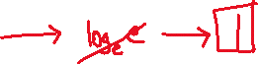

This is a natural log, the implied base is :



e)



This is a natural log; rewrite the exponent:

f)



An exponent of base undoes a natural log:



# **Topic #4: Applications of Logarithms**

*Example #1* – Modeling Height with a Common Logarithmic Function

The percentage of adult height attained by a boy who is years old is modeled by the function:

where represents the boy’s age (from 5 to 17) and represents the percentage of his adult height.

Let x be:



Let f(x) be:



a) What is the domain? Explain what the domain means in the context of this problem.



b) What percentage of his adult height will the boy attain at age 8? Round to the nearest hundredth percent.



c) What percentage of his adult height will the boy attain at 15? Round to the nearest hundredth percent.



d) When will the boy reach 80% of his adult height?

This gives an output and the equation:



Use technology to solve the equation; on a graphing calculator, let the left side equal y1 and the right side equal y2. Find the intersection:



